**Video Games Sales Data Analysis Report using Python**

**Done By: Arfin Shariar**

**Email:** [**arfinshariar.dhk2000@gmail.com**](mailto:arfinshariar.dhk2000@gmail.com)

**Introduction**

This report presents an exploratory data analysis (EDA) of a video game sales dataset. The aim of the analysis is to uncover insights into video game sales patterns across various regions and platforms, identify the most popular genres, and explore global trends in the gaming industry.

**Dataset Overview**

Dataset has been taken from Kaggle.com. Dataset has different attributes such as Rank, Name, Platform, Year, Genre, Publisher, NA_Sales, EU_Sales, JP_Sales, Other_Sales, Global_Sales

**Dataset Link:** <https://drive.google.com/file/d/1Dcnc1Giak1soe5mUDnnPxjQNYq7ASUAj/view?usp=drive_link>

**Code & Analysis Report**

Environment Setup

import numpy as np

import seaborn as sns

import pandas as pd

from matplotlib import pyplot as plt

import plotly.express as px

import plotly.io as pio

pio.renderers.default = "notebook"

import warnings

warnings.filterwarnings("ignore")

Drive Mount

#Mounting Google Drive

from google.colab import drive

drive.mount('/content/drive')

#Read CSV File

dataset = pd.read_csv("/content/drive/MyDrive/Data Analysis & Machine Learning/Video Game Data Analysis/video games sales.csv")

dataset.head()

dataset.tail()

dataset.info()

EDA

dataset.isnull().sum()

dataset["Year"] = dataset["Year"].fillna(dataset["Year"].mean())

dataset['Publisher'] = dataset['Publisher'].fillna('chandu',inplace=True)

dataset.isnull().sum()

dataset.duplicated().sum()

dataset.columns

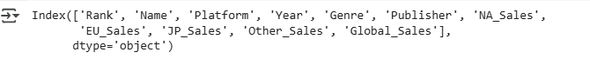

dataset.describe().plot(kind="bar")

plt.figure(figsize=(10,6))

sns.countplot(x="Year",data=dataset)

plt.title("Year Wise List")

plt.legend()

plt.show()

plt.figure(figsize=(10,5))

sns.boxplot(x="Genre",y="NA_Sales",data=dataset)

plt.title("Genre wise North America Sales")

plt.legend()

plt.show()

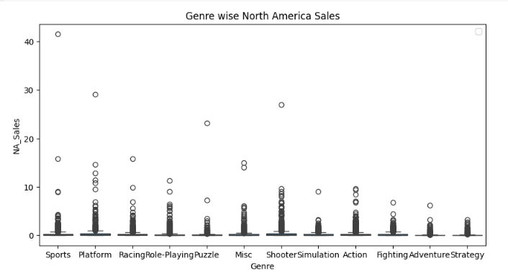

plt.figure(figsize=(10,6))

dataset["Platform"].value_counts().plot(kind='bar',color='y')

plt.title("Platform wise Sales")

plt.legend()

plt.show()

plt.figure(figsize=(10,6))

sns.violinplot(x="Platform",y="EU_Sales",data=dataset)

plt.title("Platform wise EU Sales Report Violinplot")

plt.legend()

plt.show()

plt.figure(figsize=(10,8))

sns.heatmap(dataset.corr(numeric_only=True),annot=True,cmap='plasma')

plt.title("Heatmap for finding Co-relations")

plt.legend()

plt.show()

plt.figure(figsize=(10,8))

sns.scatterplot(x="Platform",y="JP_Sales",data=dataset,color="plasma",hue="Platform")

plt.title("Platformwise Japan Sales")

plt.legend()

plt.show()

numerical_col = dataset.select_dtypes(include=np.number).columns

plt.figure(figsize=(10,6))

for col in numerical_col:

    sns.histplot(data=dataset,x=col,kde=True,bins=20,color='pink')

    plt.ylabel('Frequency')

    plt.title(f'The distribution of {col}')

    plt.legend()

    plt.show()

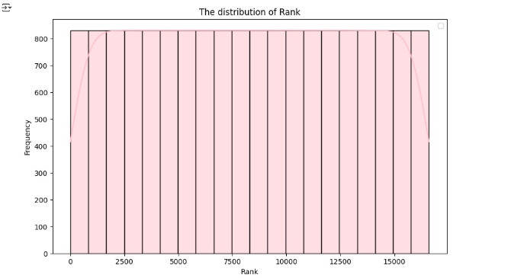

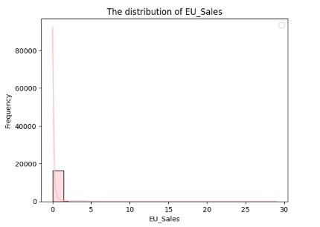

plt.figure(figsize=(5,5))

sns.pairplot(data=dataset)

plt.title('The pairplot data info')

plt.legend()

plt.show()

**[THE END]**